Dear HCAT Parents/Carers

2nd November 2020

Temporary adjustments to the school week due to Covid

Our priority at HCAT over the next few weeks, is to keep schools open to allow as many pupils as possible to attend. During this difficult period, we are experiencing unprecedented numbers of staff unavailable for work. In order to maintain the highest possible quality of education and to minimise the risk to pupils and staff, from W/c Monday 9th November HCAT primary schools will close to pupils after lunch on a Friday.

This will mean that the staffing can be redirected. This will ensure schools have more capacity to cover for Covid related staff absences. This is a temporary measure and will be reviewed towards the end of term. This will take effect from Friday 13th November after lunch. Your individual school will notify you of exact timings in the coming days.

I understand this may be of some inconvenience however it is an essential measure to keep schools open. We would appreciate your continued support and understanding in these difficult times.

Yours Faithfully
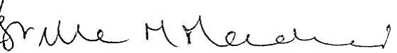

Estelle Macdonald
CEO HCAT

